Lecture 8 - Exercises

Question 1: Select optimal columns for biomolecule purification

What columns or chromatography techniques would you need to complete the following biomolecule purification experiments:

a. Separate two proteins based on differing molecular weights

b. Separate a mixture of lipids based on differing hydrophobic properties

c. Separate a mixture of DNA molecules that have different lengths (e.g., 20, 40 and 60 nucleotide base pairs)

d. Purify a tagged protein from other cellular biomolecules

Question 2: Select an optimal expression system for your protein

What expression systems would you choose for the expression of the following proteins? Why or why not and explain:

a. 12 kDa single-domain protein of bacterial origin, residing in cytoplasm (example: KaiB oscillator protein)

b. 280 kDa multi-domain protein of human origin, residing in cytoplasm (example: mTOR kinase)

c. 15 kDa disulfide-linked chemokine of mouse origin, secreted outside the cell (example: Interleukin 11)

d. 249 kDa multidomain, N-glycosylated, transmembrane protein of human origin (example: integrin)

e. 194 MDa virus of bacterial origin (example: T4 bacteriophage)

Question 3: Affinity purification

You would like to purify a human intracellular protein (Protein X) which has a molecular weight of 40 kDa and is associated to several diseases. Based on sequence analysis and AlphaFold structure prediction, you conclude that it consists of a single domain and is not expected to undergo any post-translational modifications. Further, the protein does not have any cysteine residues that can form disulfide bridges. You added a poly-histidine tag to the C-terminus of the protein to facilitate purification.

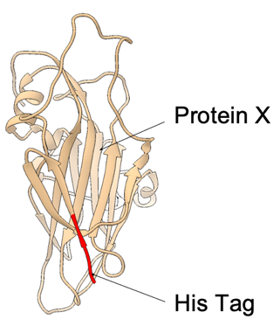

a. Which expression system would you first test for this protein and why?

- b. Following the expression in the host chosen previously, you continue with affinity chromatography in order to purify the protein. Describe the specific type of affinity purification you’ll employ and identify which part of the protein is required for this method. Additionally, explain the working principle of this technique and specify the type of column you’ll be using.

c. Select the minimal set of necessary buffer components that should be included in the Elution Buffer for the his-tag purification step?

Reagent | Yes | No | Why?
20mM Tris-HCl
0.1% Triton-X
150mM NaCl
5mM DTT
10mM Ribose
20% Glycerol
0.1mM Imidazole
500mM Imidazole

d) For the His-Purification you obtain the following chromatogram. Label the peaks 1, 2 and 3 and explain what proteins are in each peak. In blue you can follow the UV absorbance of the protein at 280 nm and in green the concentration of imidazole. Was this a step-wise or a gradient-based elution with imidazole?

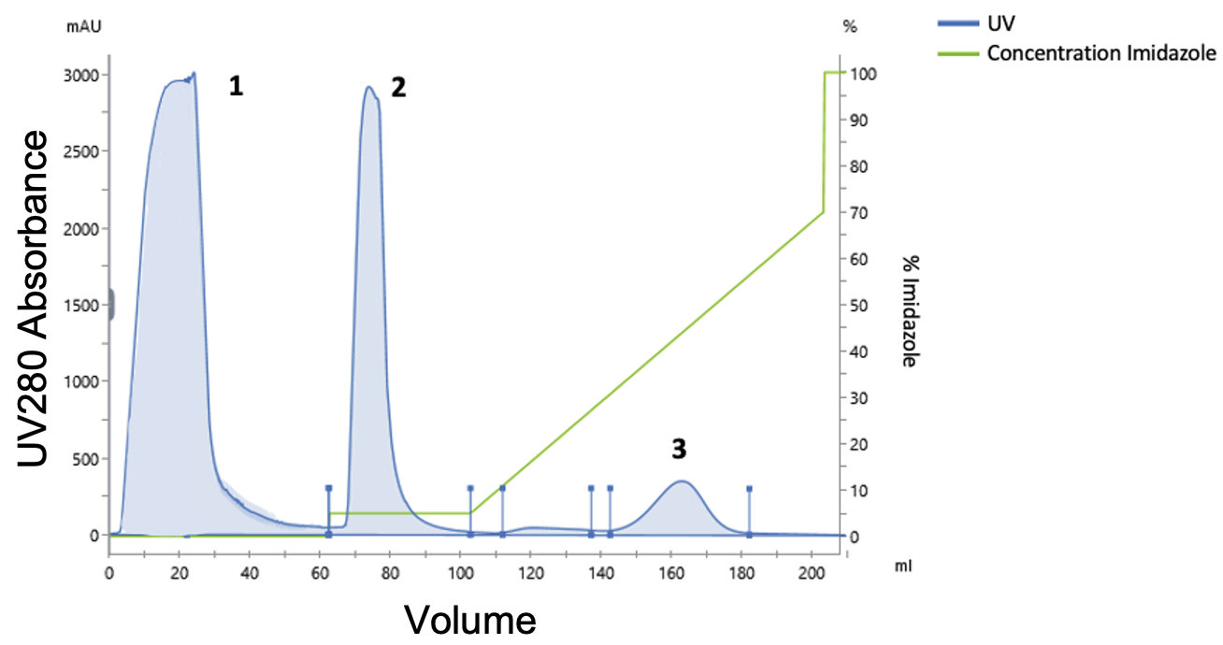

e) To assess the purity of your protein of interest, you decide to run an SDS-PAGE under reducing conditions. You load the gel with: a protein ladder, the original lysate from E. coli that you injected into the His-column ("Input"), and small amounts of samples taken from fractions corresponding to peaks 1, 2, and 3. Examine the gel: Which fractions contain the protein of interest? Does it match the predicted molecular weight based on the sequence? Evaluate whether the purification was successful and what could be improved next time?

f) You suspect that your protein (Peak 3 from the previous step) may be partially aggregated, which will lead to problems with downstream structural and functional analyses. So you decide to separate the monomeric and aggregated forms of the protein using Size-Exclusion-Chromatography. How does size-exclusion chromatography work? Looking at the chromatogram, where is the aggregated and where is the soluble protein?
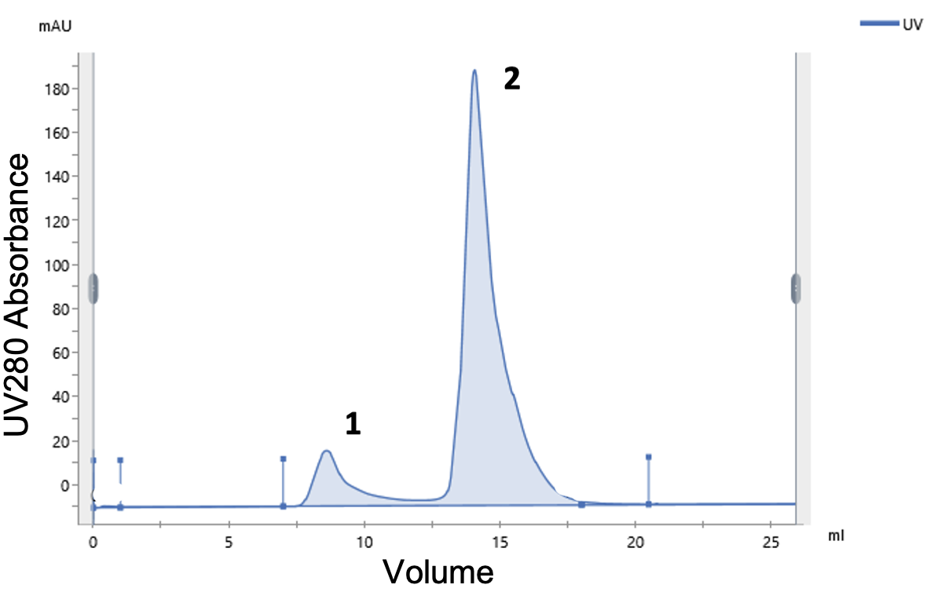

Question 4: Separating proteins by charge

You are working with a Protein Y with a molecular weight of 50 kDa that has a pI of 5.5. After the initial affinity purification you realize that the protein is contaminated with other protein species, so you decide to increase the purity of your protein by separating it based on charge, using ion-exchange chromatography.

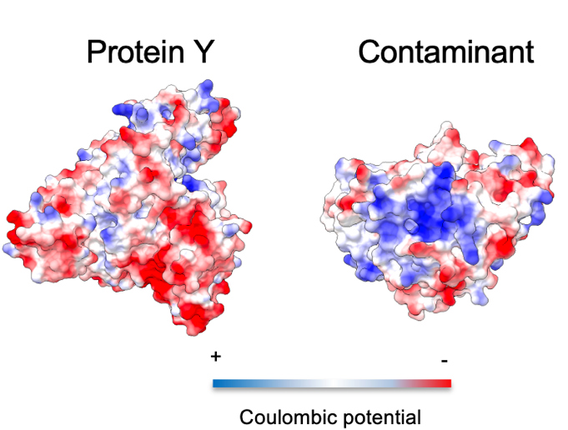

- Using a buffer of ph=7.5 what is the net charge of the protein? What subtype of column would you use to bind it?

- What are the different ways that you can use elute proteins from this type of column?

- You elute the protein from the column using a linear gradient of NaCl and get the following chromatogram. In the chromatogram you follow the protein by looking at its absorption at 280 nm (UV). By increasing the relative percentage of the “elution buffer” (green) you slowly increase the salt (NaCl) concentration loaded onto the column which triggers the elution of the protein. You can follow the increase in salt concentration by looking at the increase in conductivity (orange). You observe that the contaminating proteins elute before your protein of interest. Why is that the case? What does the position of the peak depend on when eluting with salt?
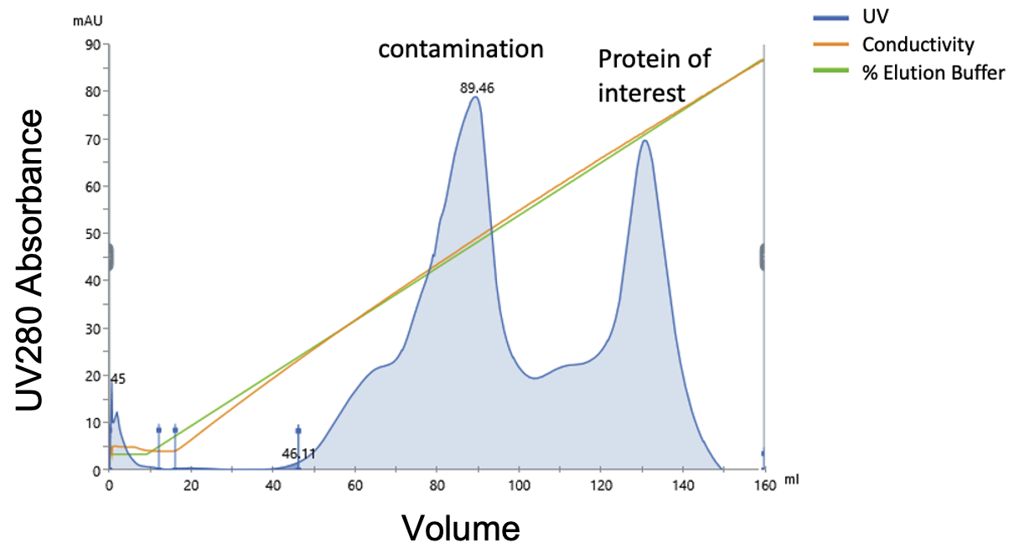
Question 5: Purification of strep-tagged proteins

You are working with an enzyme with the predicted molecular weight of 30 kDa (based on amin-acid sequence). In nature this protein needs to dimerize in order to be in its’ functional state. The dimeric state is further stabilized by 2 disulfide bonds formed between the monomers.
The protein has been engineered with a C-terminal Strep-Tag and recombinantly expressed in E. Coli.

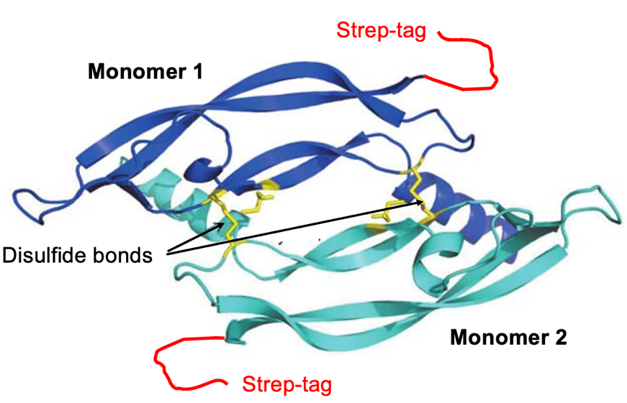

- What type of affinity column would you use to purify this protein?

- Select the minimal set of necessary buffer components that should be included in the Elution Buffer for this purification step?

Reagent | Yes | No | Why?
20mM Phosphate buffer (pH 7.5)
0.1% Triton-X
150mM NaCl
10mM Cellulose
5mM DTT
20% Ethanol
20mM Biotin
500mM Imidazole
3M MgCl₂

- After purification you obtain the following chromatogram which shows more peaks than you anticipated. To determine which peak contains the pure protein you run small amounts on an SDS PAGE gel under reducing conditions (+ DTT). Which peak contains the pure protein of interest? Please explain.
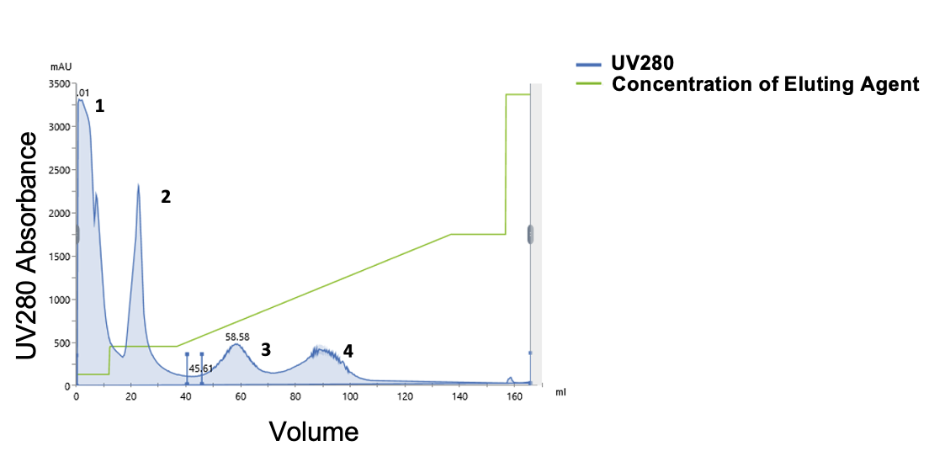
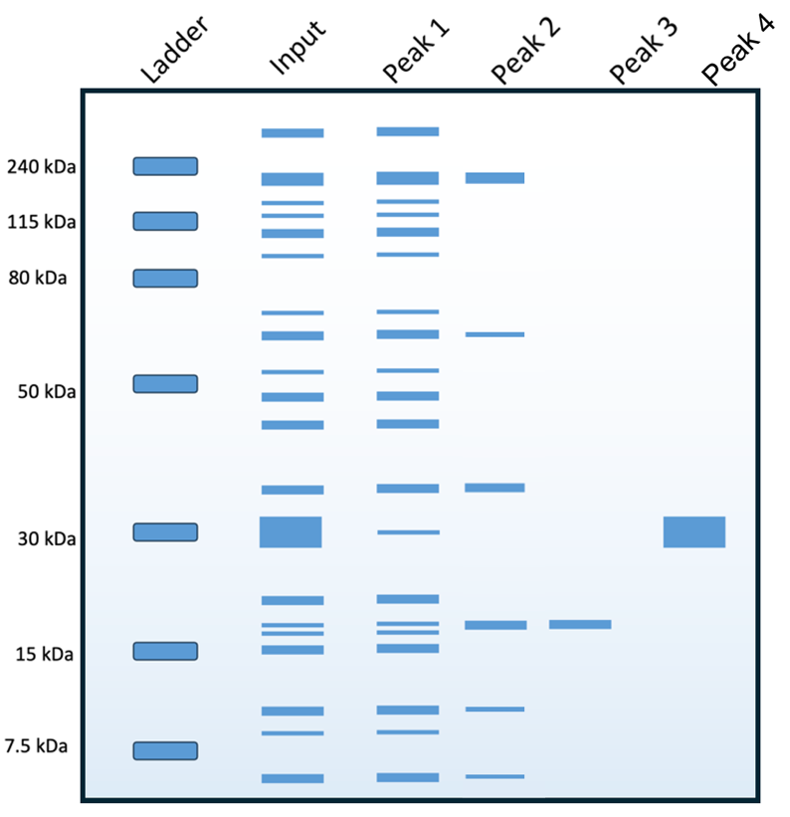

- To separate different oligomeric states of the protein (monomer vs dimer) you perform size-exclusion chromatography. In the chromatogram you see two peaks and you get very excited because you assume that one of the peaks belongs to the dimeric active form of the enzyme. Which peak corresponds to the monomer and which peak to the dimer based on the elution volume?
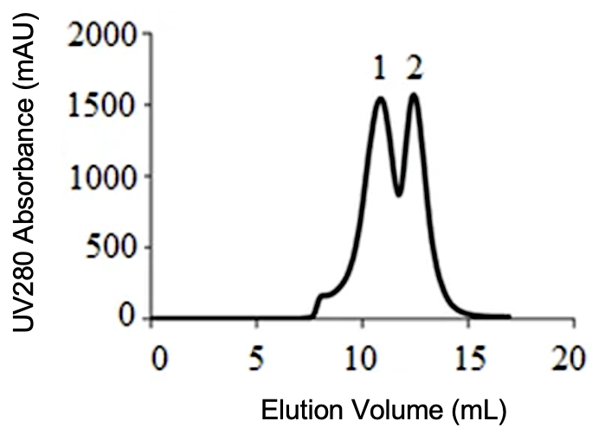

- You take a small amount of each peak and denature it under reducing (+DTT) and non-reducing (-DTT) conditions, followed by SDS PAGE analysis. The results are shown below. What can you say about the status of inter-monomeric disulfide bonds in Peak 1 and Peak 2? How do these results correlate to size-exclusion chromatography in terms of the oligomeric state?

